**Technical guftgu (Bhupinder Sing Rajput)**

Devops Tutorial for beginners

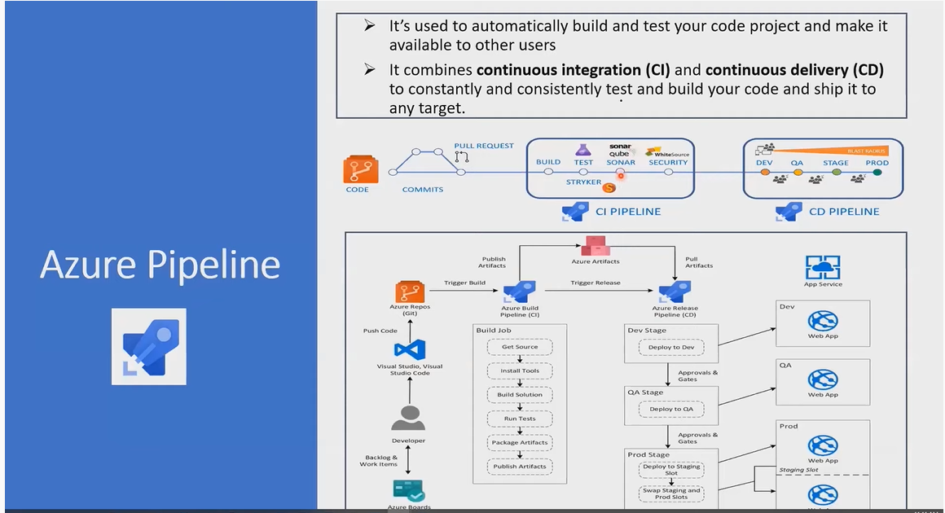

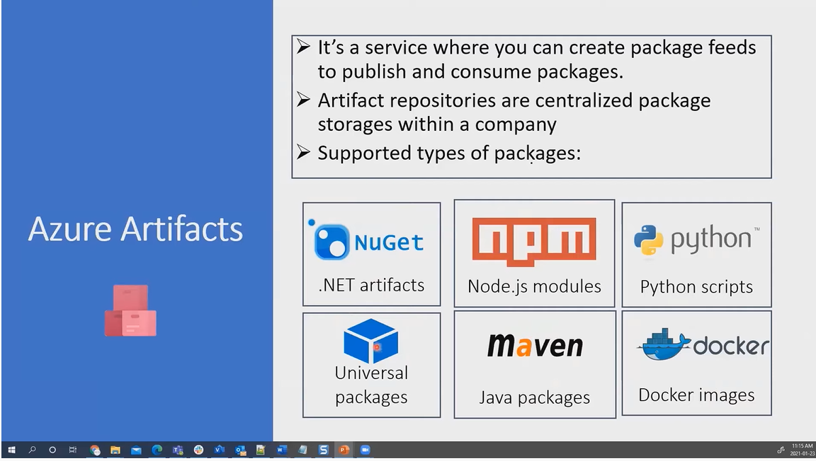

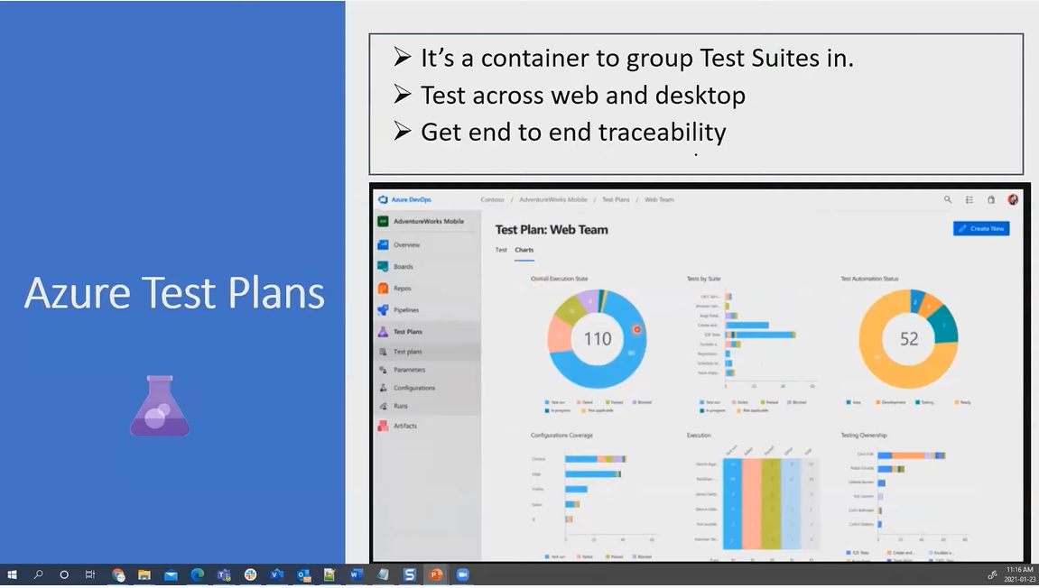

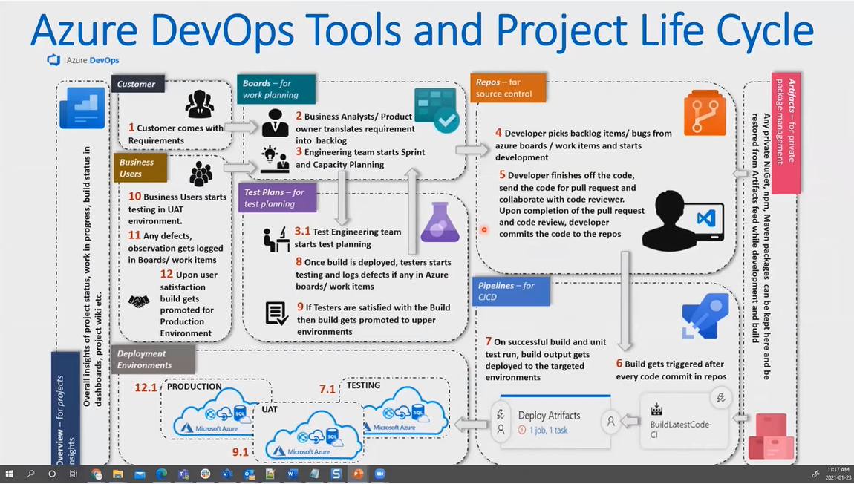

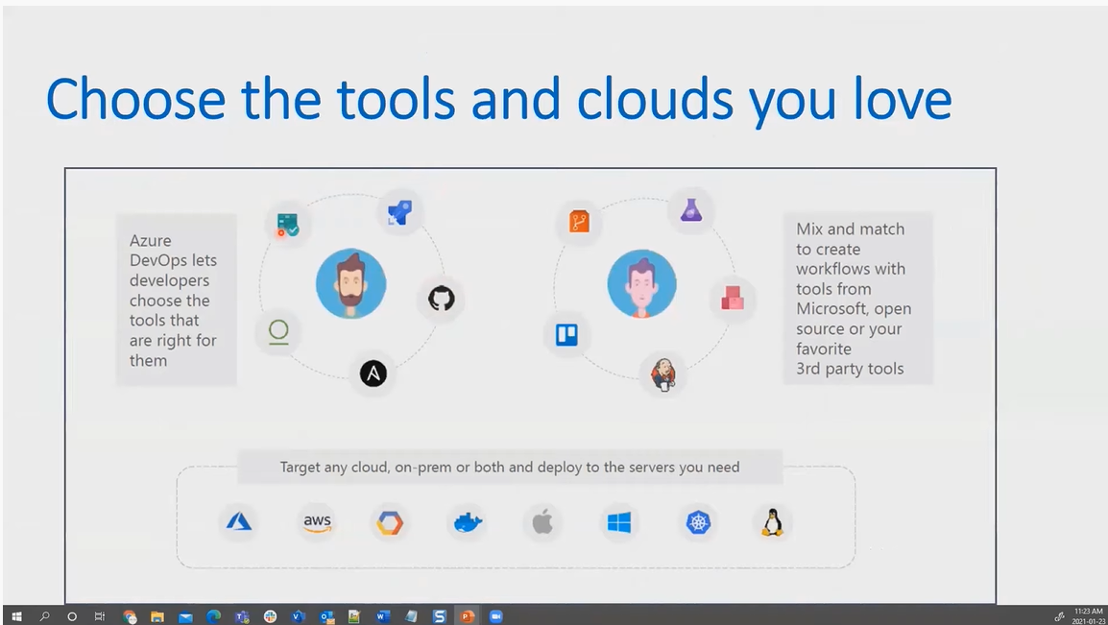

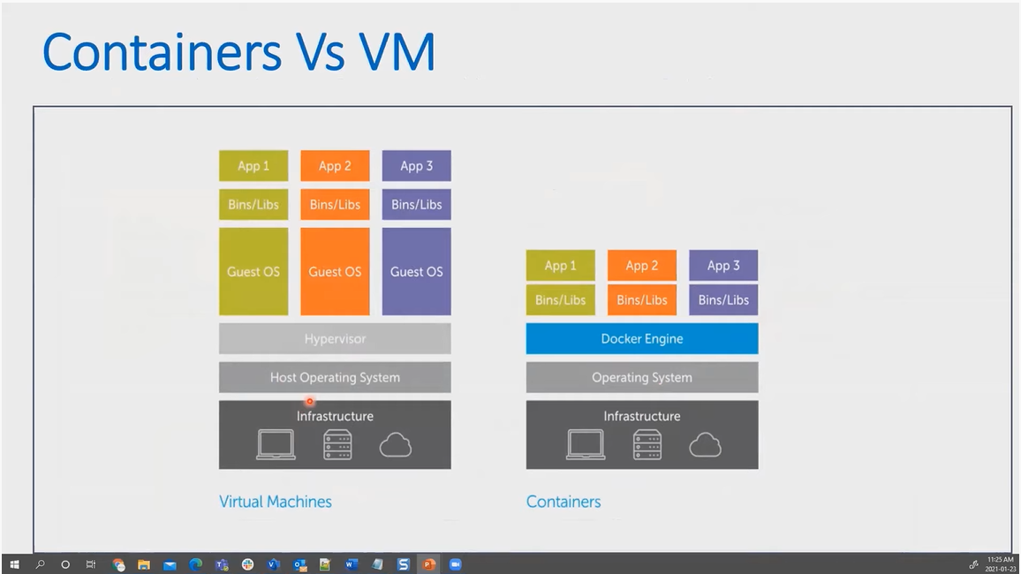

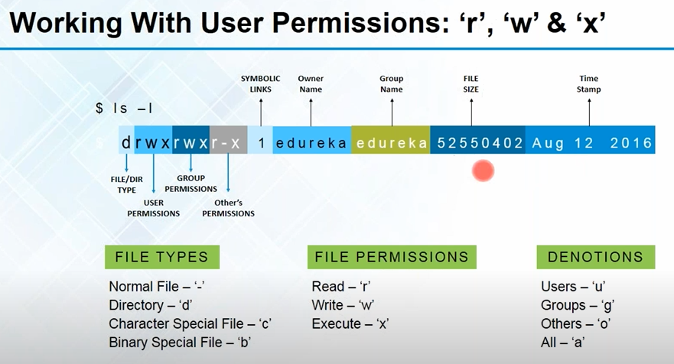

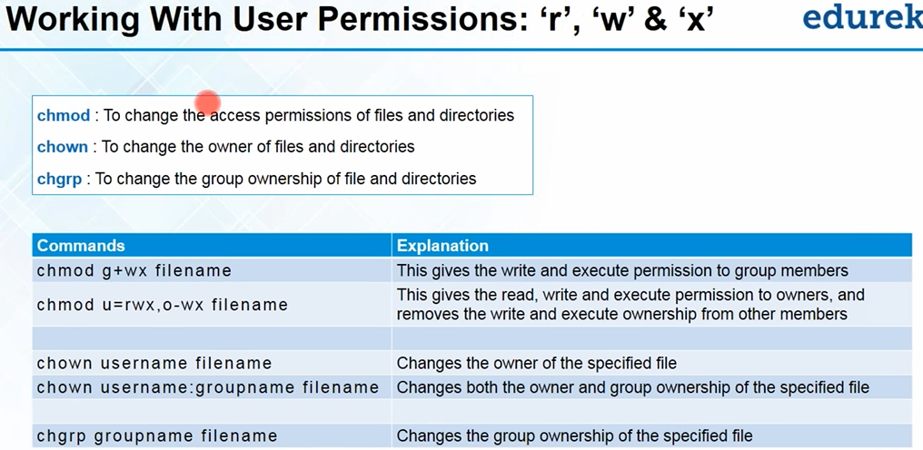

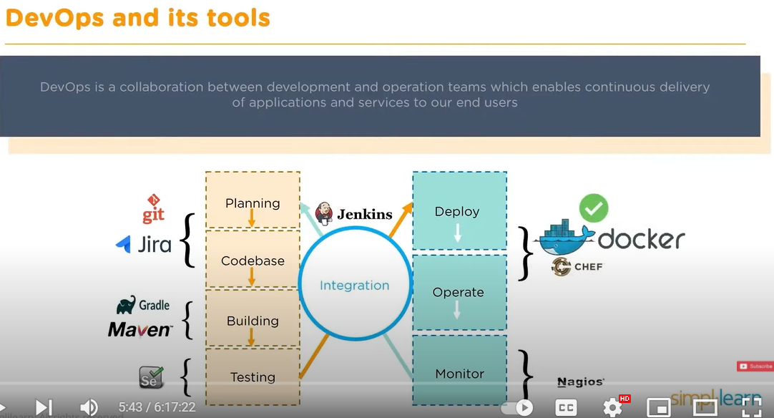

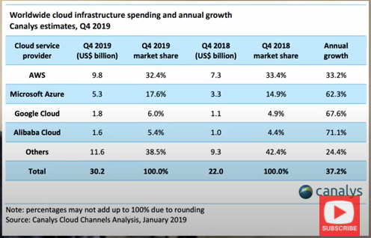

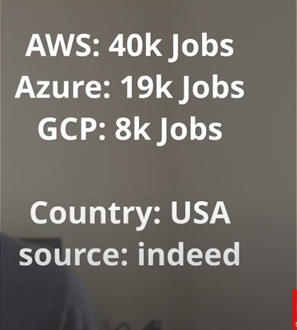

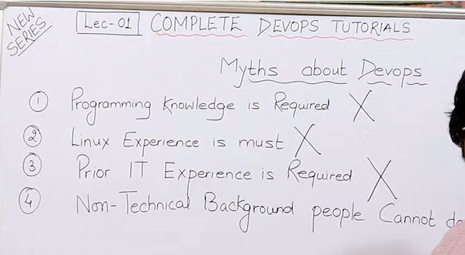

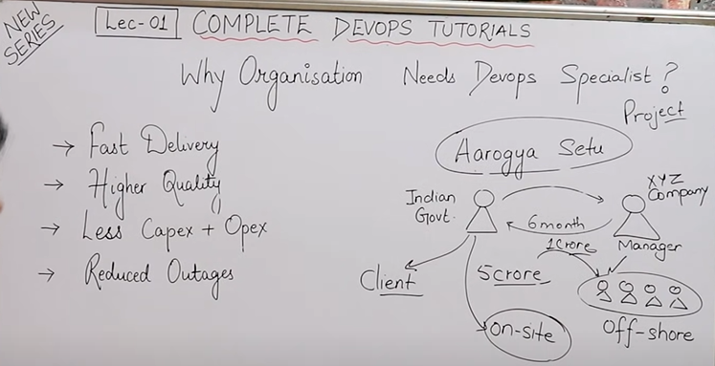

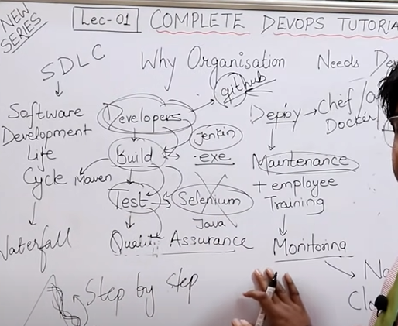

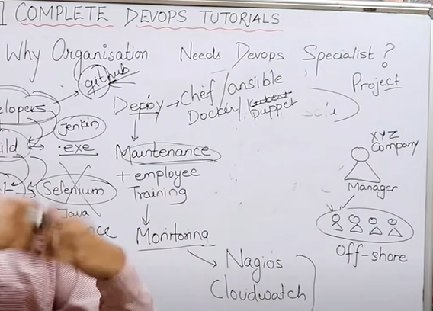

**Lecture: 2**

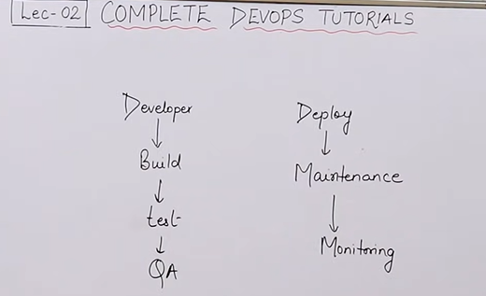

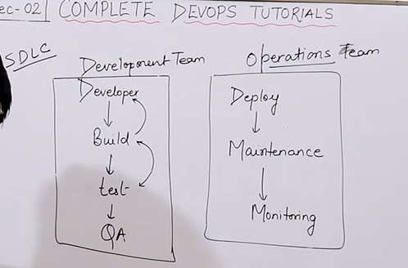

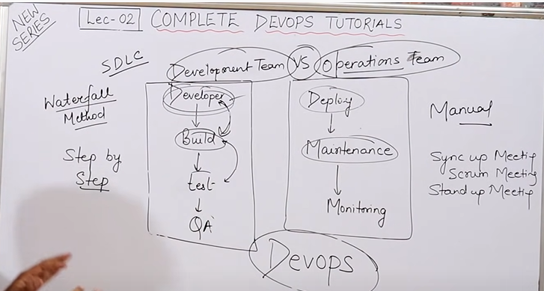

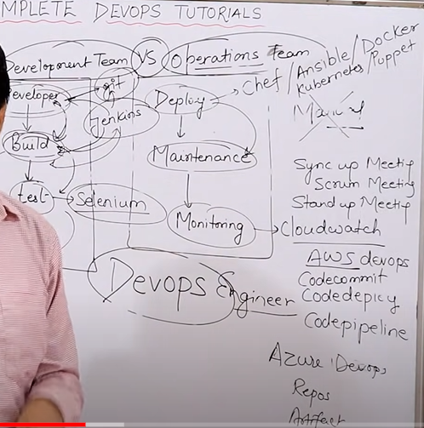

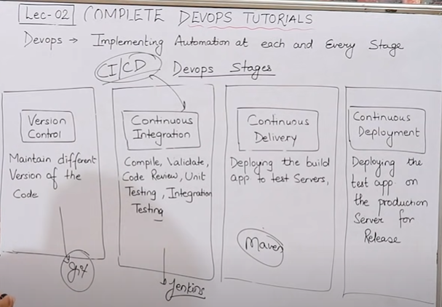

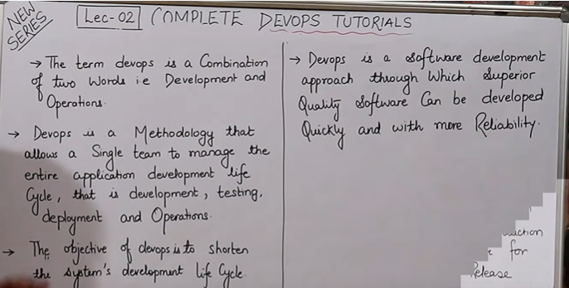

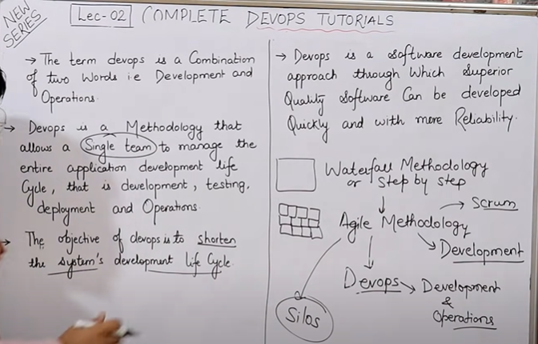

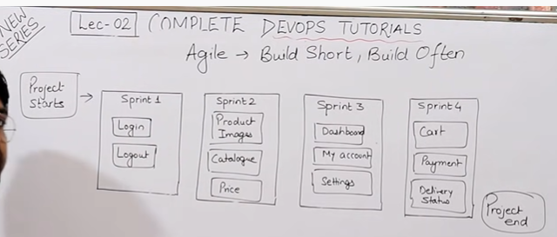

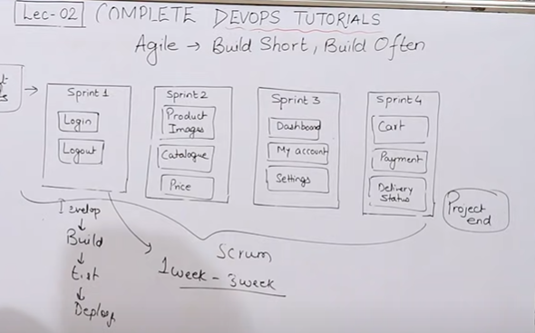

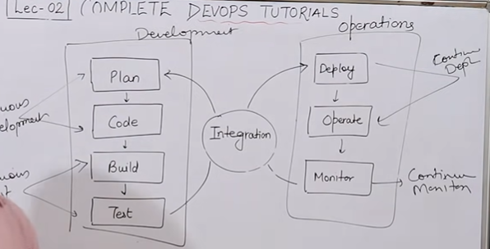

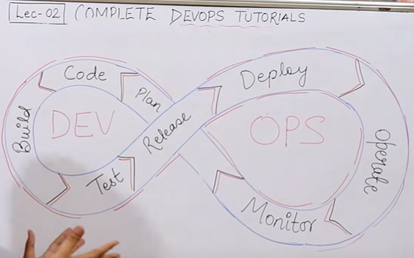

Lecture 3: Complete Devops Tutorials

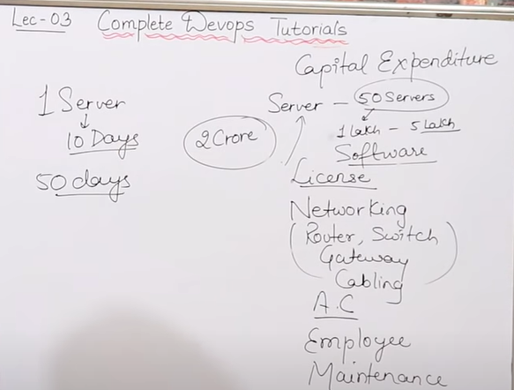

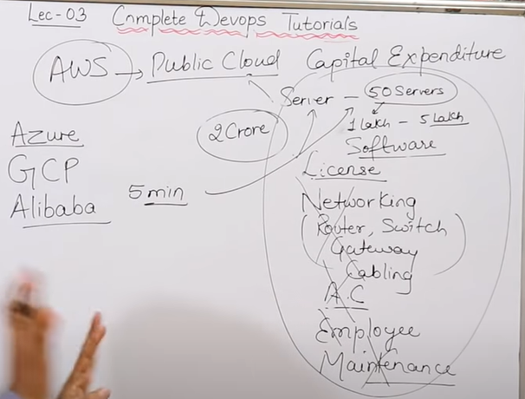

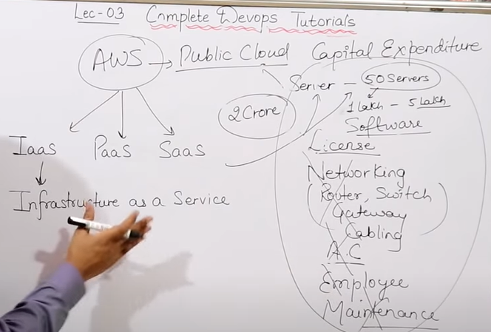

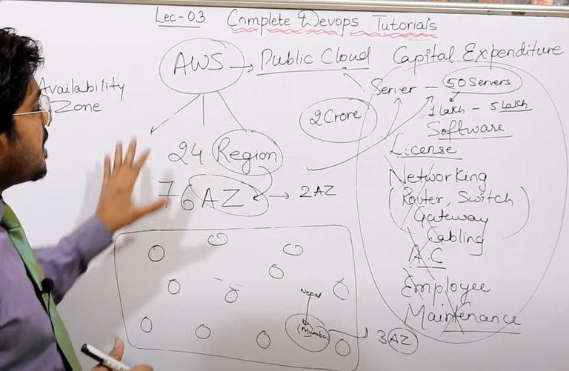

Cloud is a technology which gives you ability to share your resources from remote. Cloud is a Service which gives you resource. Ex google drive,

AWS has 24 Regions and 76 Availability Zone (AZ)

---------------------------------------------------------------------

Basics & History of Linux

1964 --> Bell laboratory in New Jersey

1969 --> It Withdraw to work on UNIX.

Dennis Ritchie and Ken thompson

UNICS--> Uniplexed Information and Computing services (free for all)

In 1975 --> UNIX V6 (became popular at that time)

UNIX flavours are as below

IBM- AIX

SUN SOLARIS

Max OS

HP -Ux

Linux (flavour of UNIX) --> Linus Torvald (1991)

Andrew Tanenbawn (Professor) -->MINIX ( linux torvald studied this programm and made Linux

Linux (kernel) +GNU ---> Operating System

Kernel is a part of operating system

Linux( Source code is available to all) many made os from Linux

RHEL

Fedora

Dabian

Others (Ubuntu, centOS,Amazon Linux, Kali linux(mostly used for hacking) )

Ubuntu --> 3rd most used OS

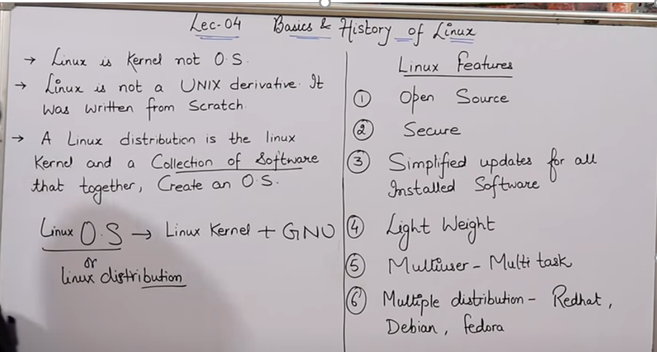

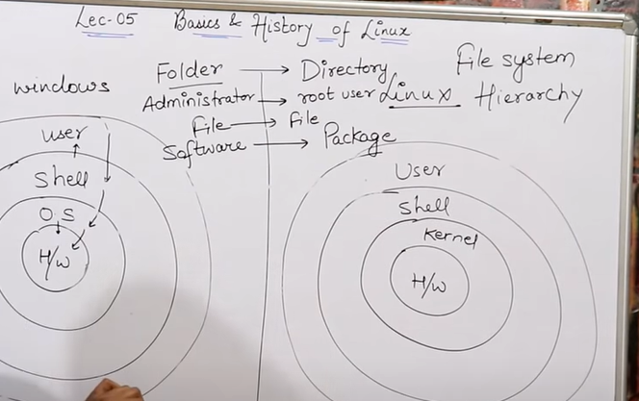

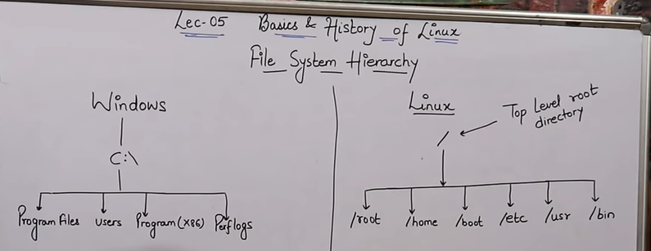

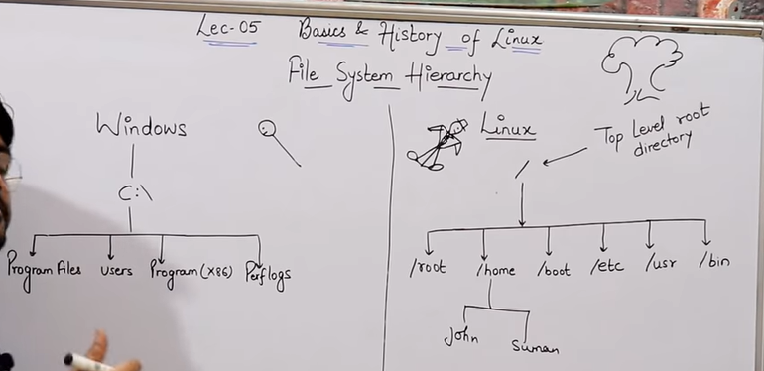

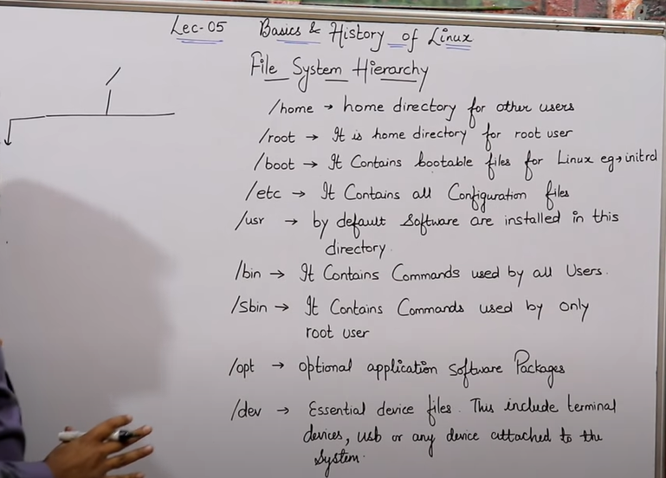

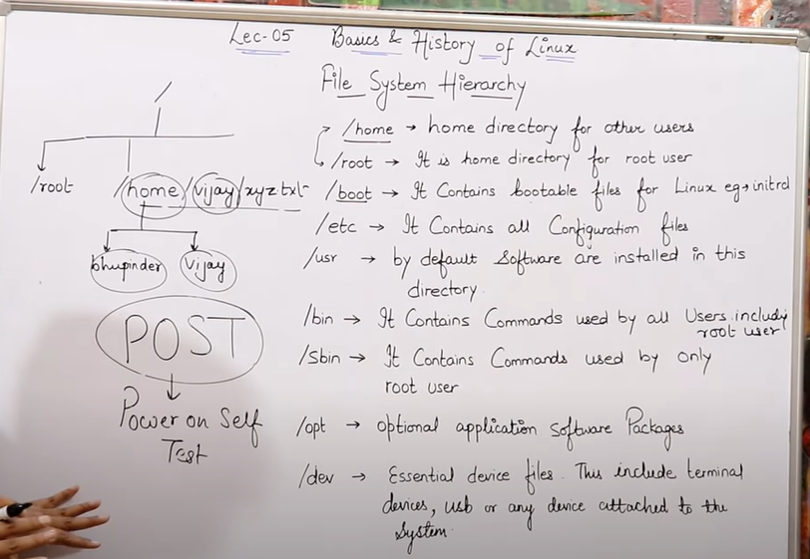

**Lecture3:**

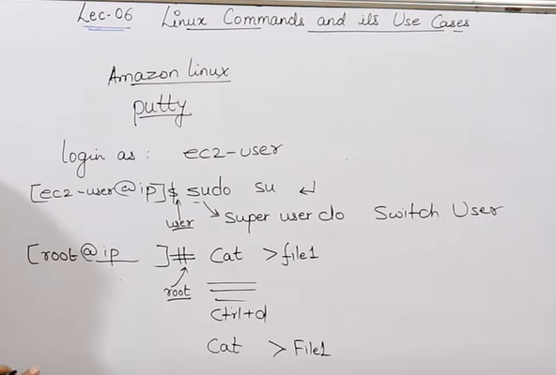

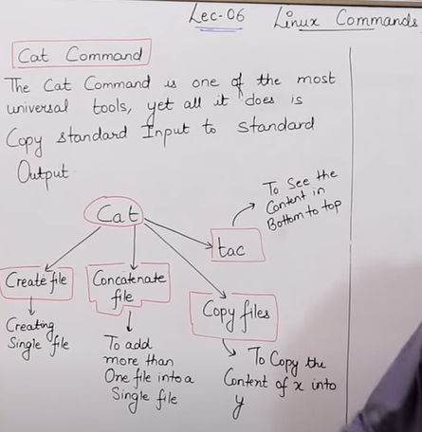

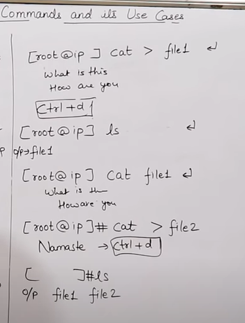

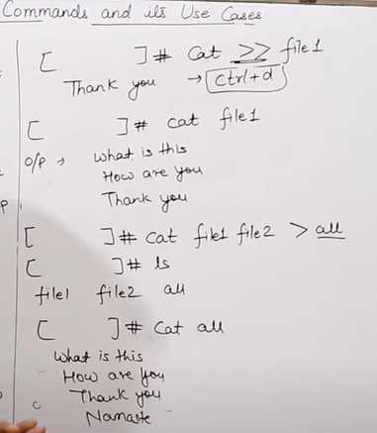

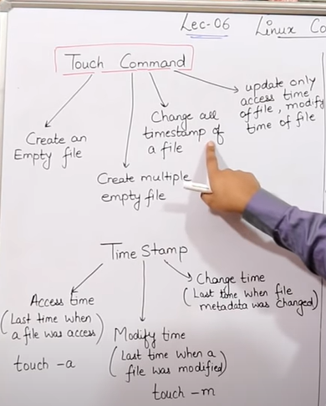

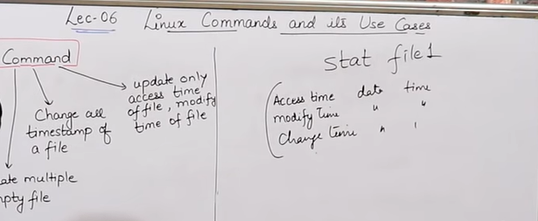

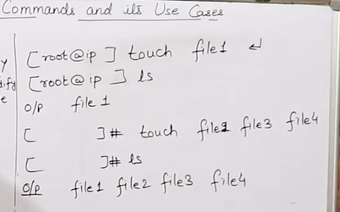

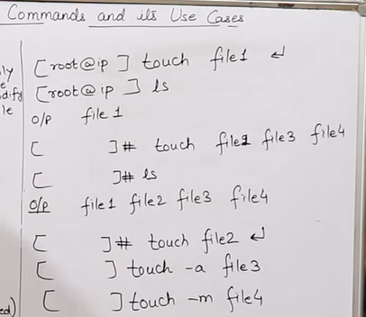

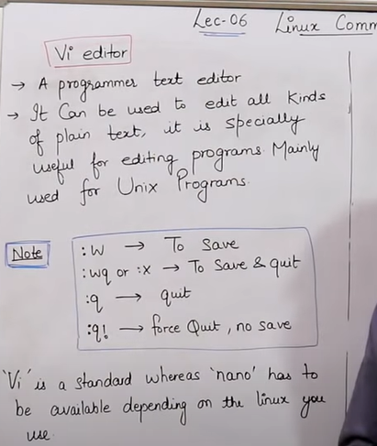

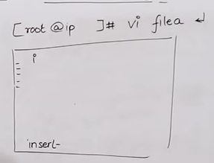

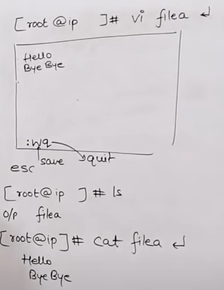

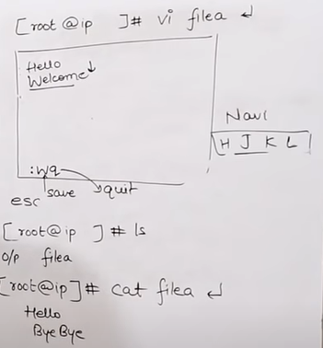

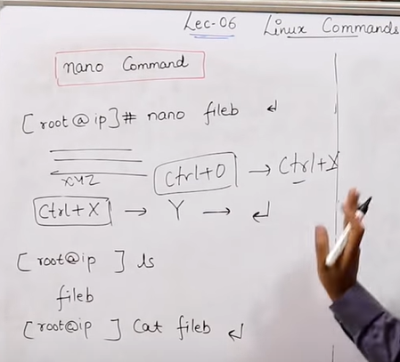

Lab

1 ls

2 cat >file1

3 ls

4 cat file1

5 cat > file2

6 ls

7 cat file2

8 cat >>file2

9 cat file2

10 cat file1 file2 >all

11 ls

12 cat all

13 cat file1 >file2

14 cat file2

15 cat file1

16 cat all

17 tac file1

18 cat all >file1

19 cat file1

20 tac file1

21 ls

22 touch file3 file4 file5

23 ls

24 cat file4

25 stat file1

26 touch file1

27 stat file1

28 touch -a file2

29 stat file2

30 touch -m file2

31 stat file2

32 ls

33 vi file6

34 ls

35 cat file6

36 vi file7

37 ls

38 file7

39 vi file5

40 cat file6

41 vi file6

42 cat file6

43 nano file8

44 ls

45 cat file8

46 nano file8

47 cat file8

48 ls

49 ls -l

50 ll

51 clear

52 ll

53 clear

54 ll

55 clear

56 ls -l

57 ls -a

58 history

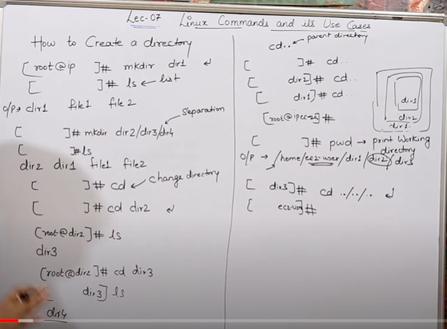

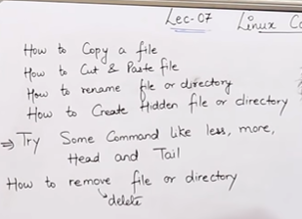

[root@ip ] # touch .file1

[ ] #ls -a (show hidden files and other files )

Make the file/folder hidden just put . in front of file/folder

[]#cp file1 file2 (copy data from file1 to file2 it will override the data of file2)

[]#mv file1 to dir1 (move file1 to directory 1)

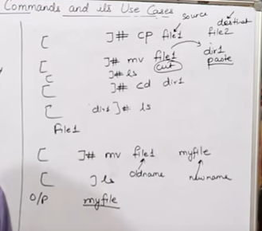

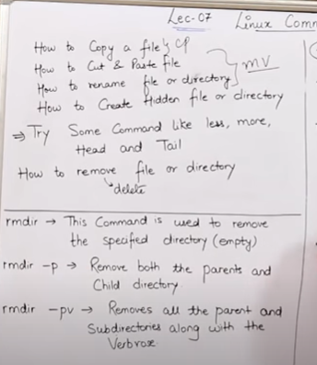

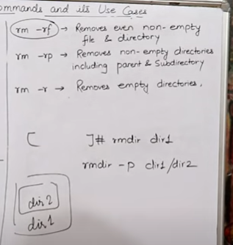

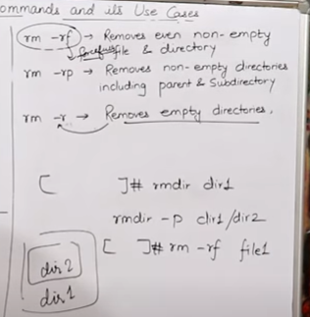

Lecture 8

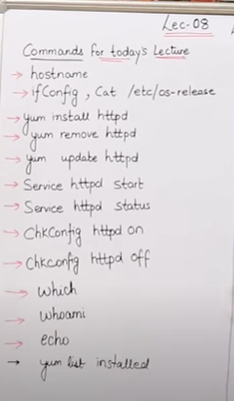

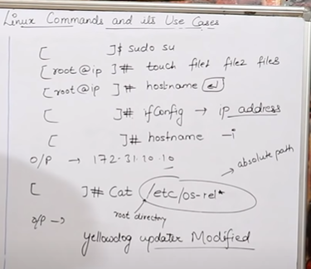

To install some software in Linux machine

Yum install httpd (httpd for apache software)

Yum remove httpd -- to remove the package

Yum update httpd -- to update package

Service httpd start – To start the service.

Service httpd status -- To check the status of service.

Service httpd stop – to stop the service

Chkconfig httpd on -- To start service automatically on backend .

Lecture 13:

How to use git and create github account

Sudo su

Yum update -y

Yum install git -y

Git –version

Git config –global user.name “dhrubaa”

Git config --global use email [bhupinder@gmail.com](mailto:bhupinder@gmail.com)

git version 2.23.4

git config --global user.name "dhruba"

git config --global user.email [truth_aryal@yahoo.com](mailto:truth_aryal@yahoo.com)

git config –list

lecture 14:

How to commit, push and pull from github

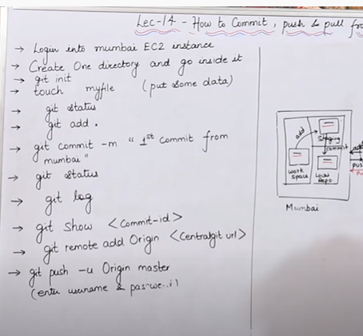

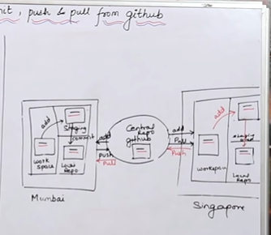

Lecture 15:

How to create Branch, Merge & Stash

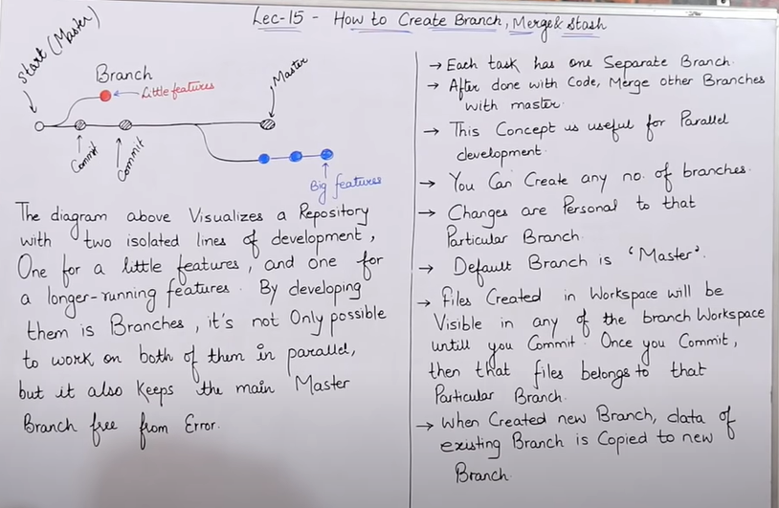

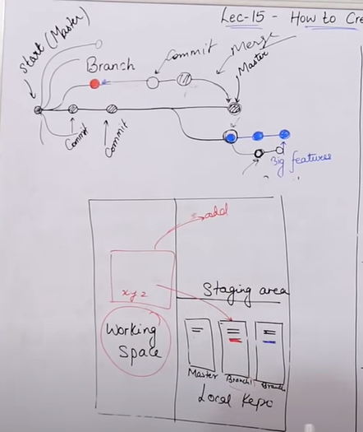

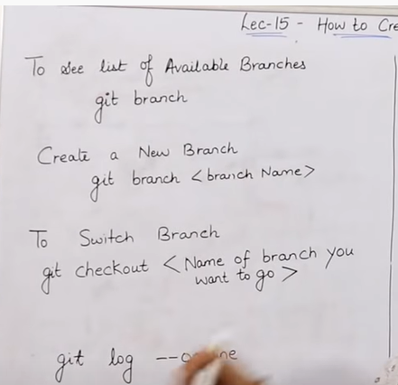

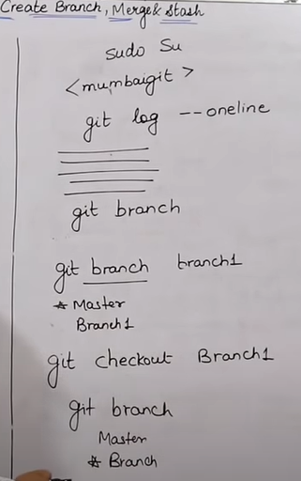

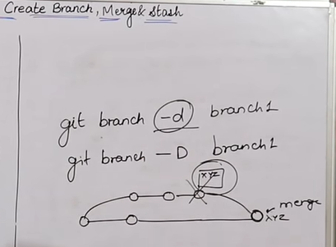

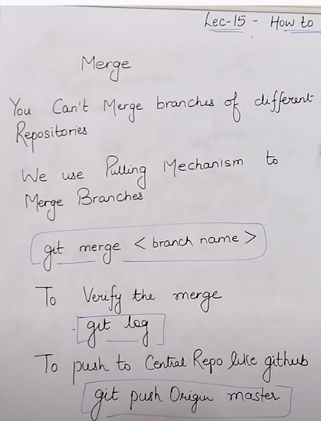

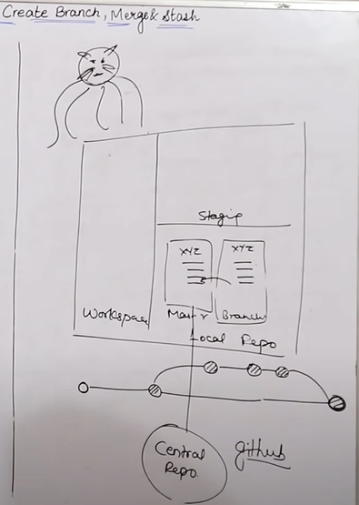

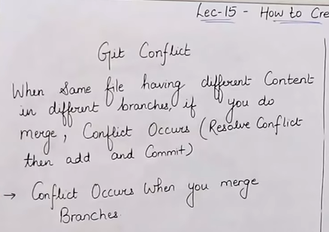

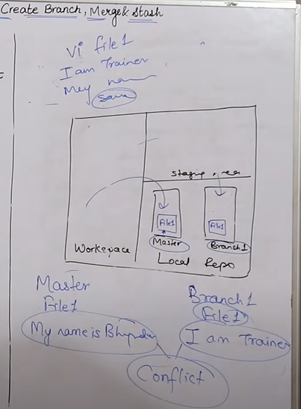

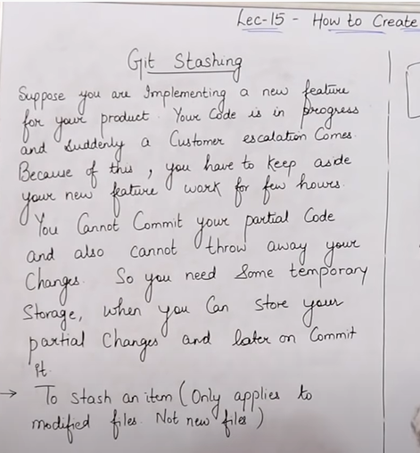

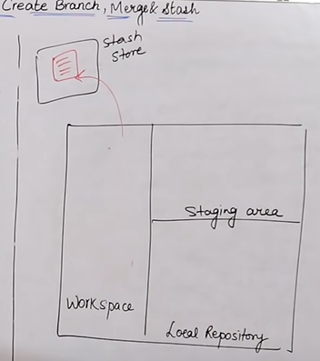

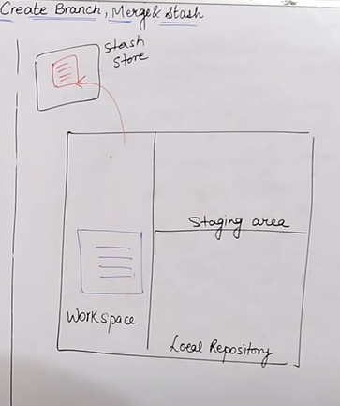

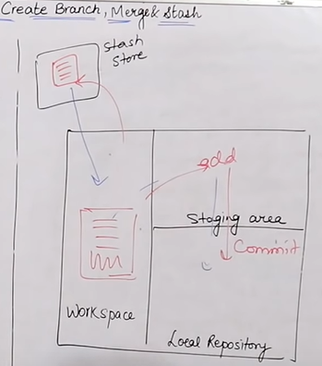

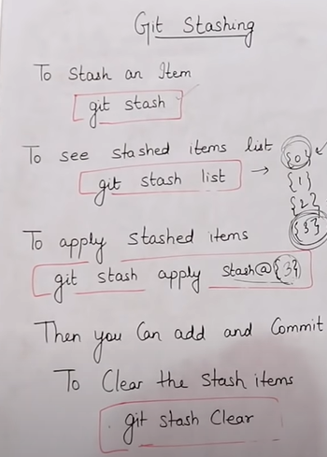

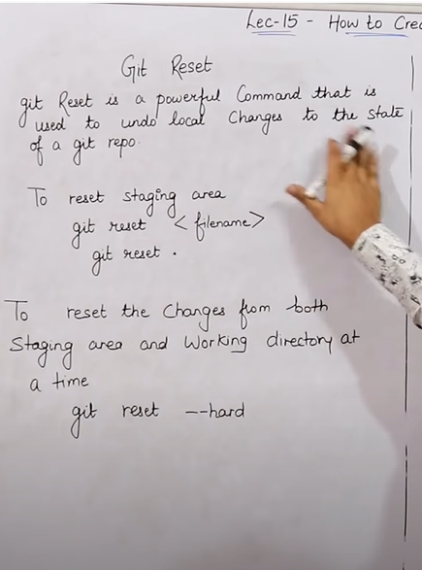

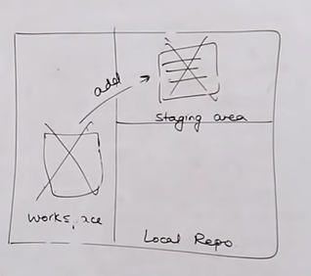

Lecture -16 How to do git revert, Tag and github clone

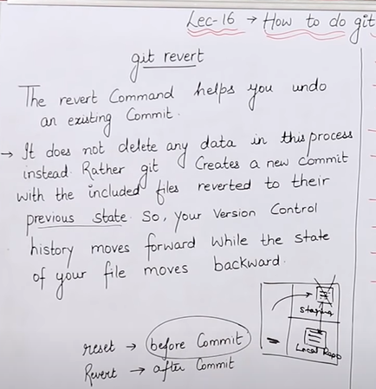

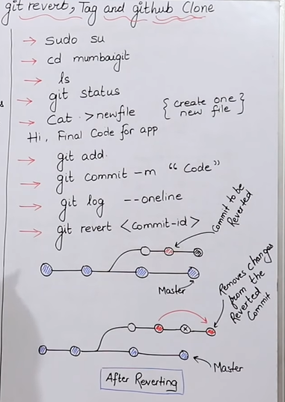

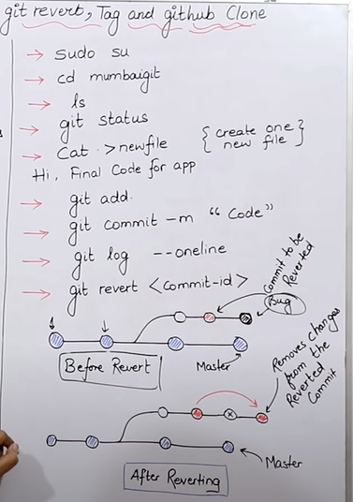

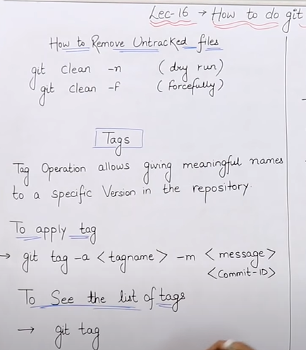

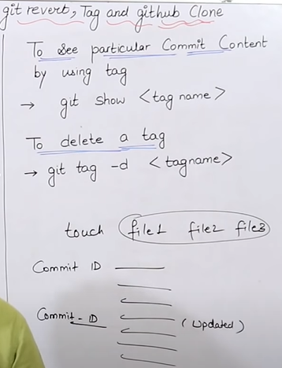

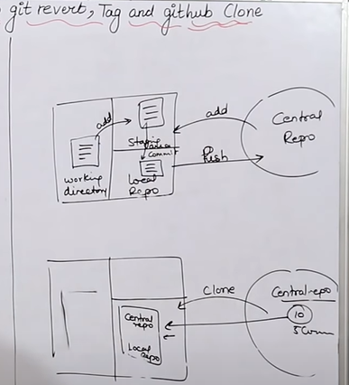

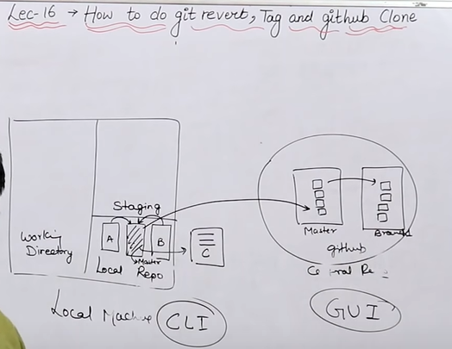

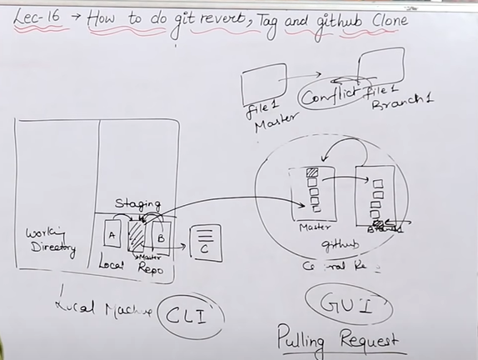

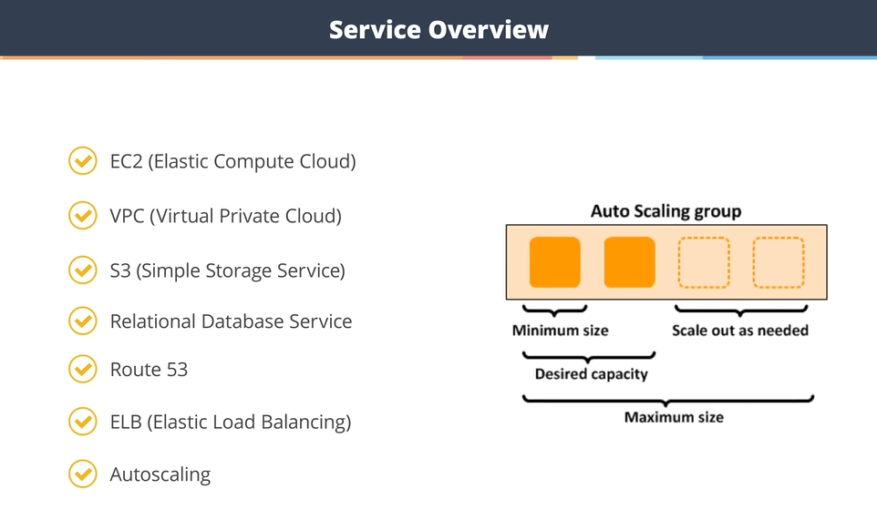

Jenkins:

Lecture:36 What is CI/CD Pipeline? What is Jenkins?

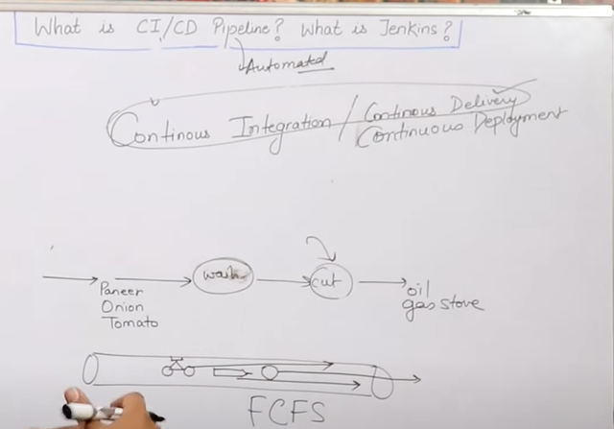

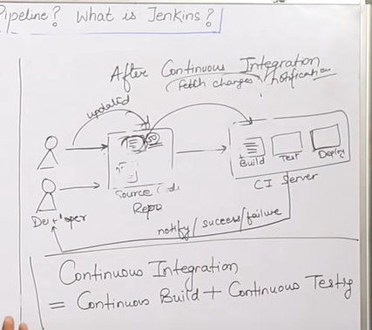

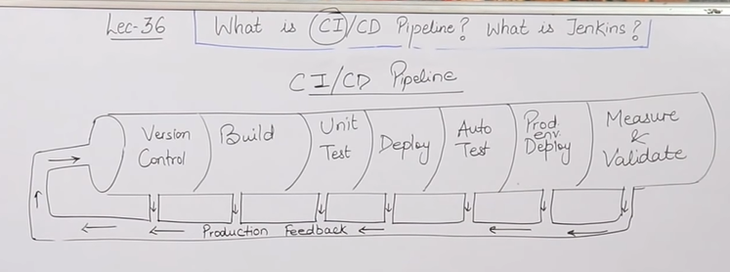

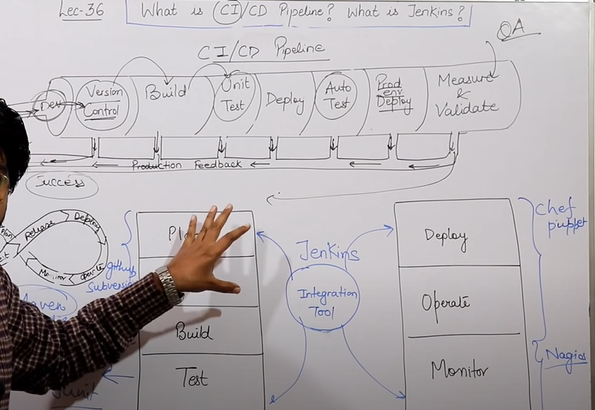

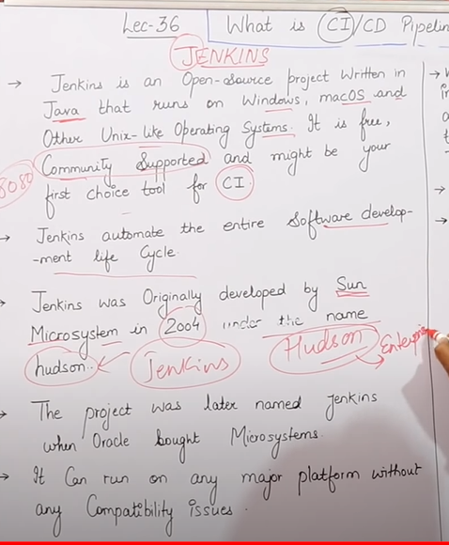

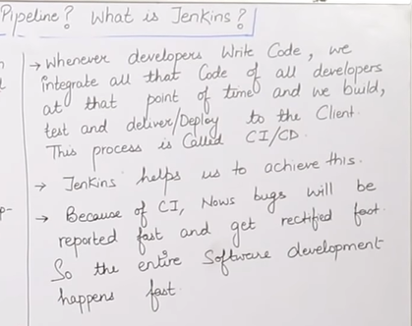

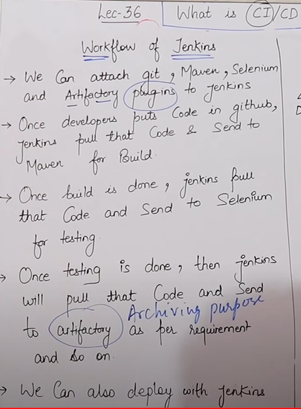

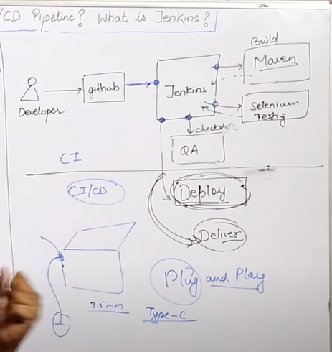

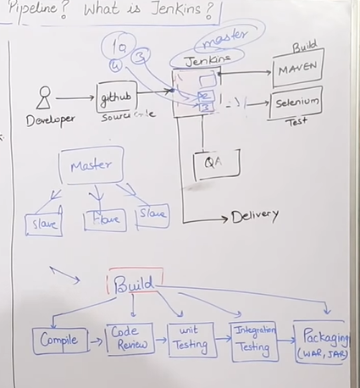

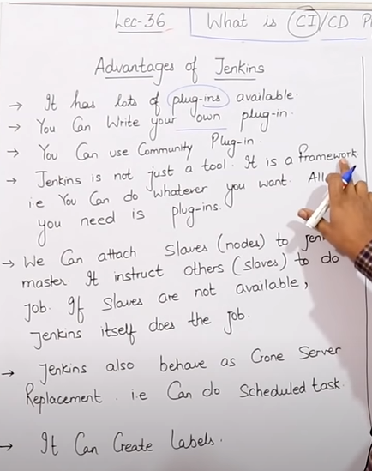

Lecture 37:

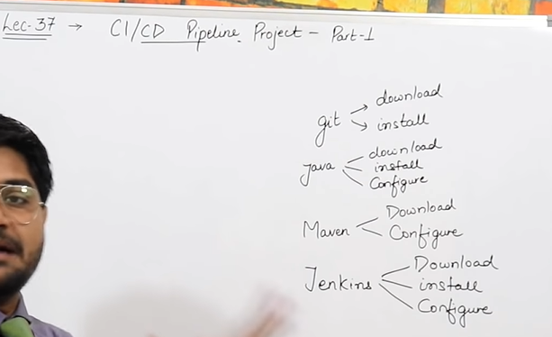

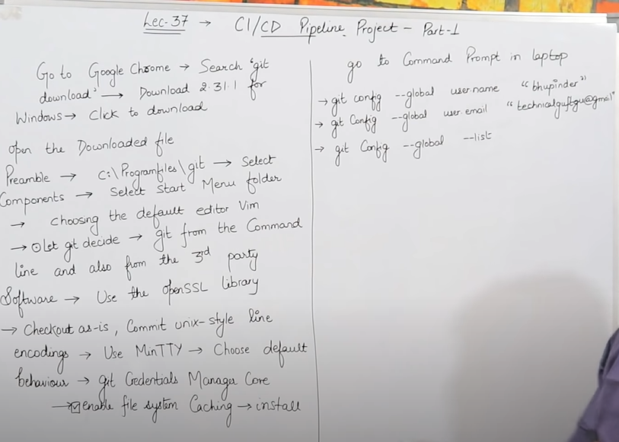

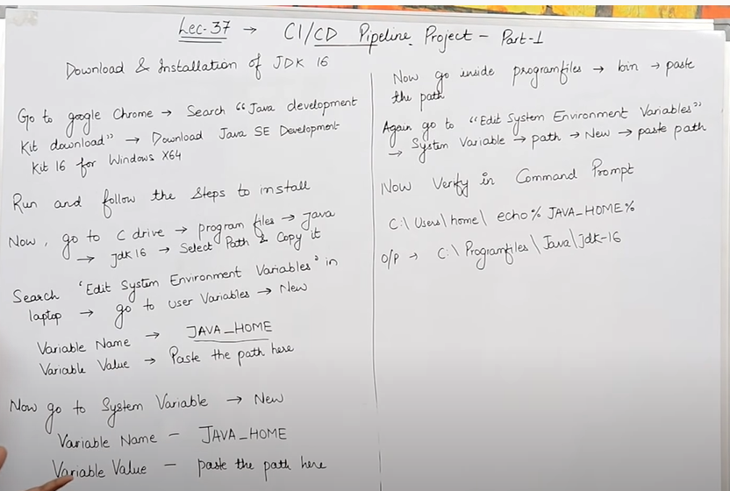

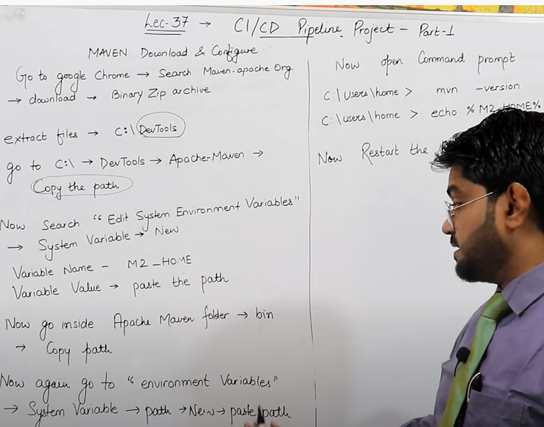

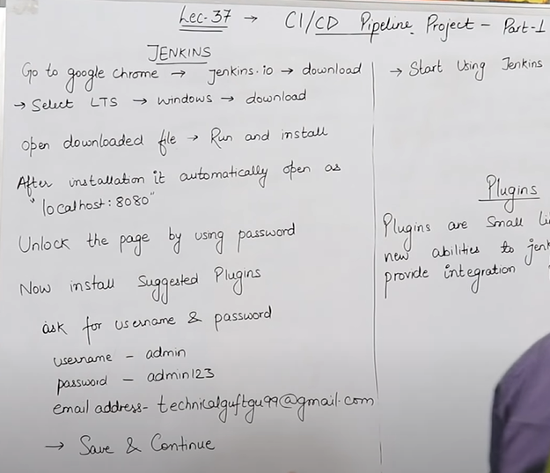

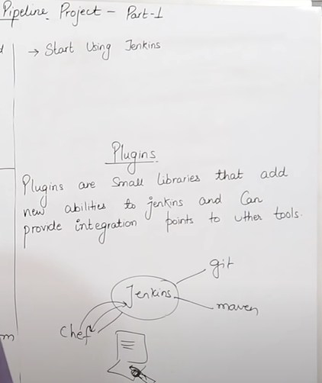

Lecture 38: maven job, Schedule Task, Poll SCM

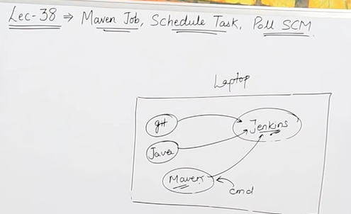

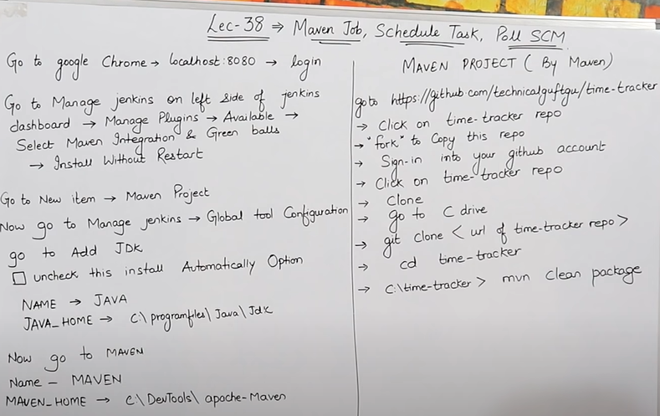

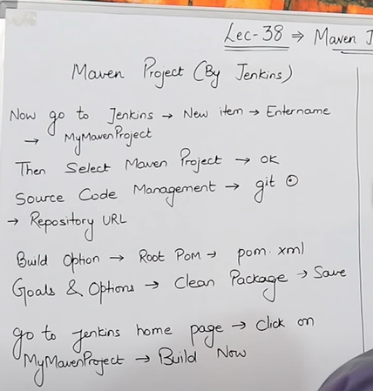

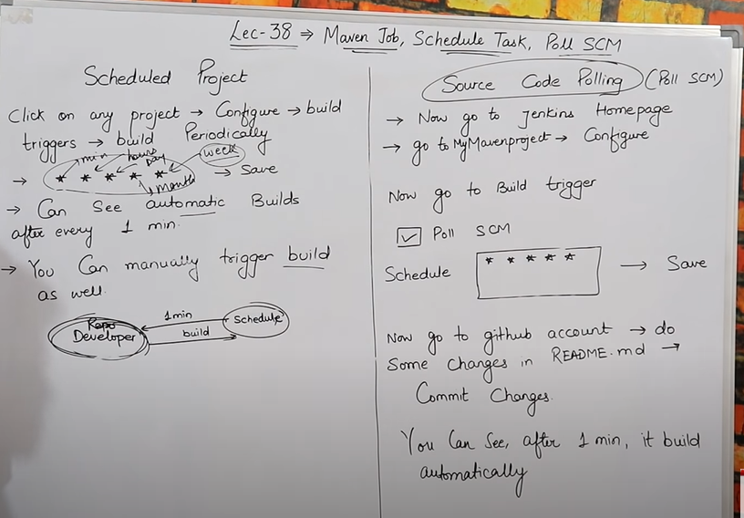

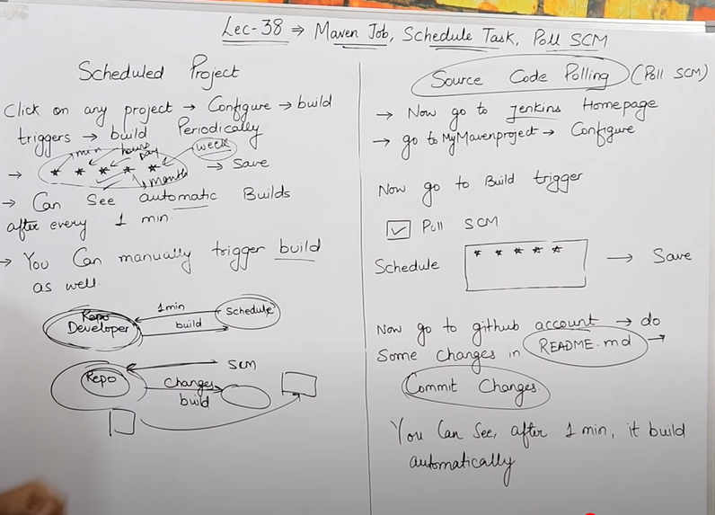

Lecture:39

Linked Projects, Views, User Management & Master-Slave Concept

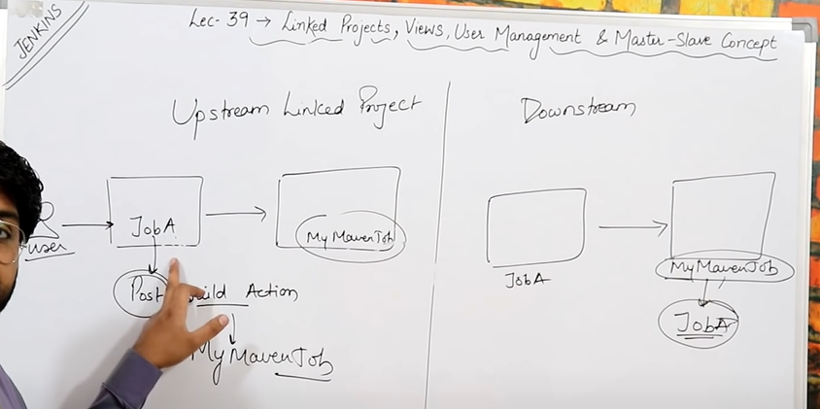

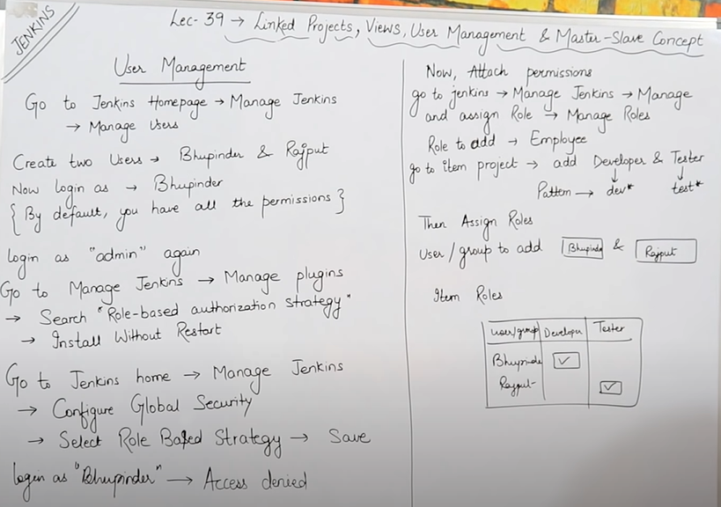

Inside the company we can access Jenkins by using 🡪 Privateip:8080

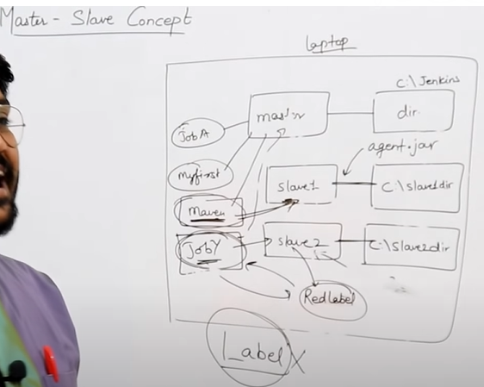

Lecture: 41 How to Install Jenkins on Ubuntu

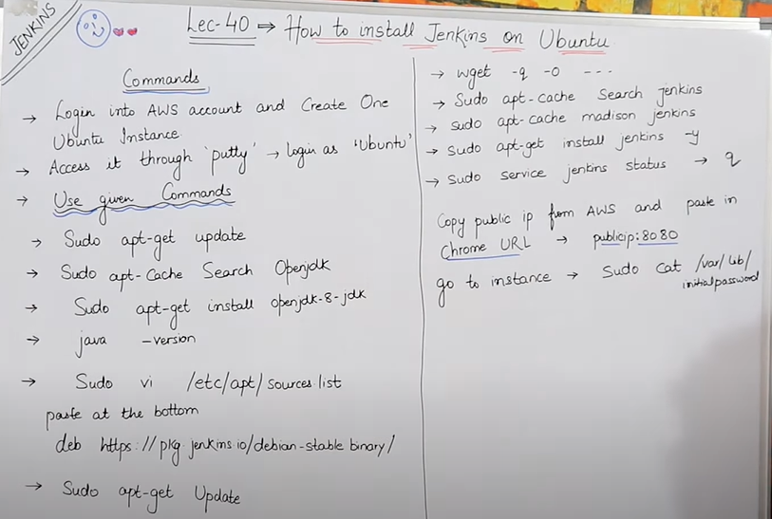

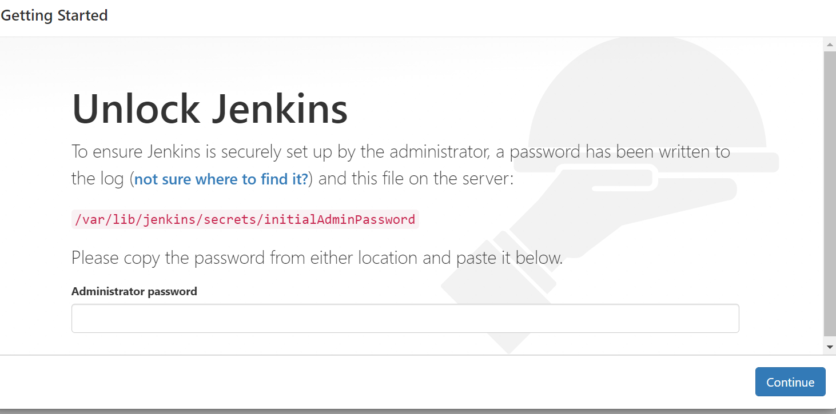

Sudo cat /var/lib/jenkins/secrets/initialAdminPassword

206f4b62c4414ee29c7bff5027b67d36

<http://54.209.153.103:8080/>

Lecture 41: What is MAVEN and why we Use it?

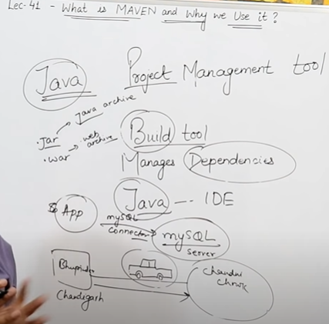

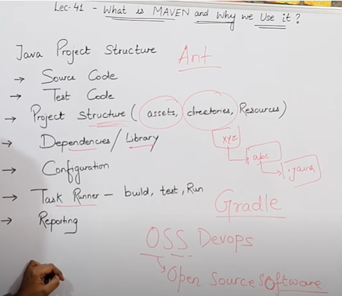

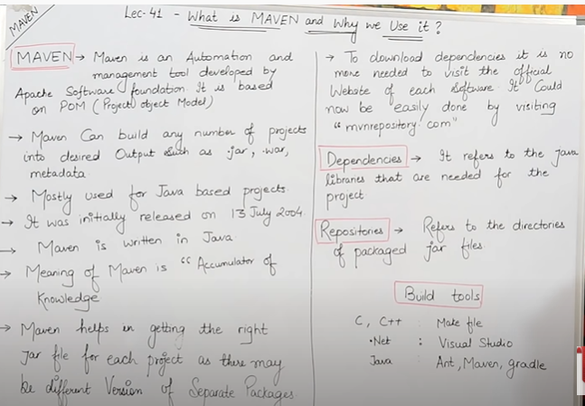

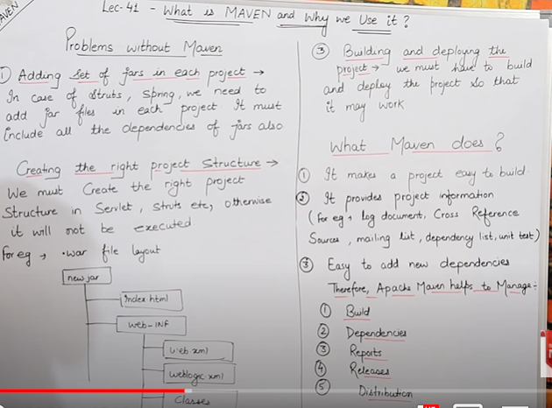

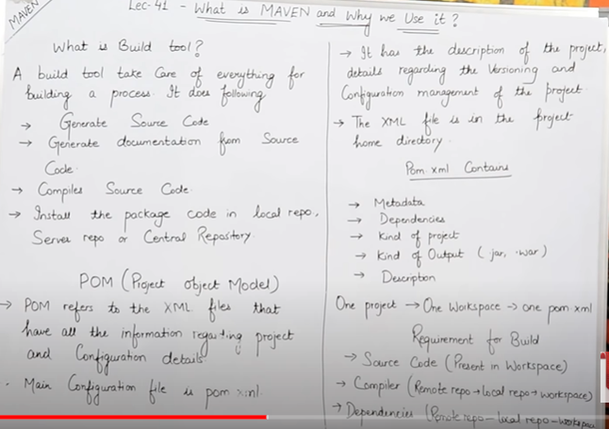

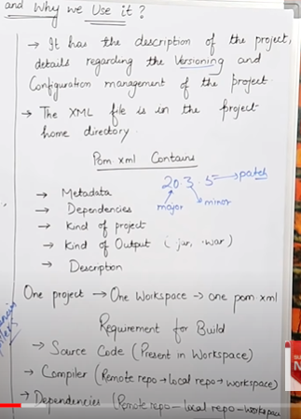

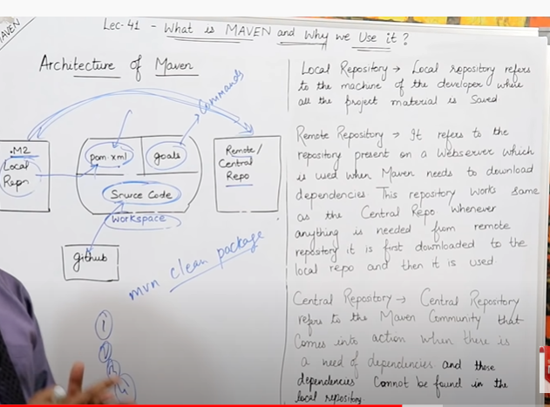

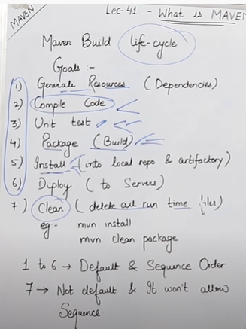



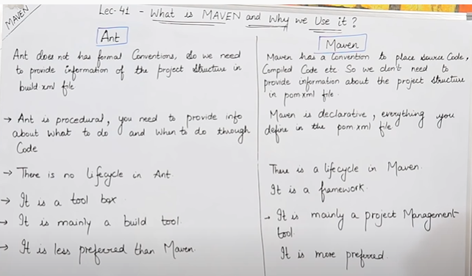

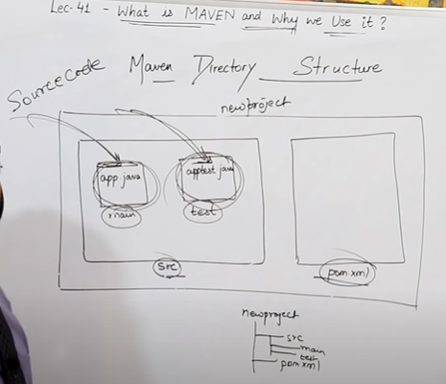

Lecture -42 🡪 Complete Devops Project

1. Git download

Install Git

Java download

1. Install java

Configure Java: System environment variable

1. Jenkins.war

Install Tomcat Server

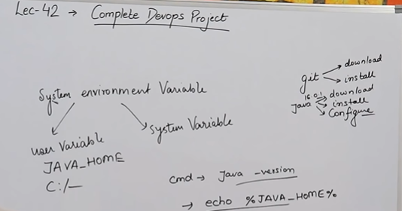

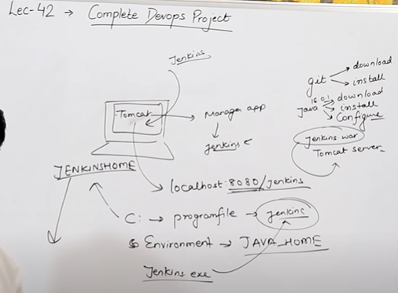

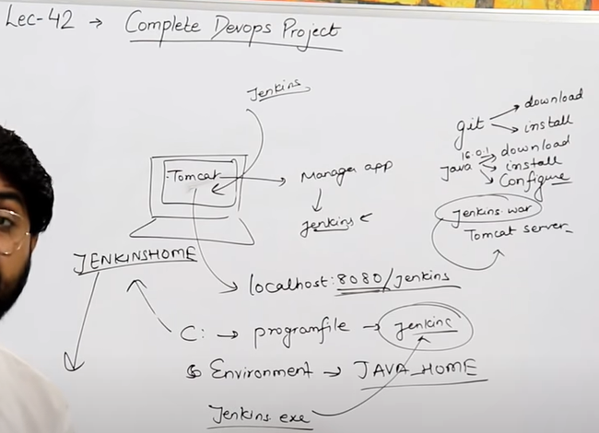

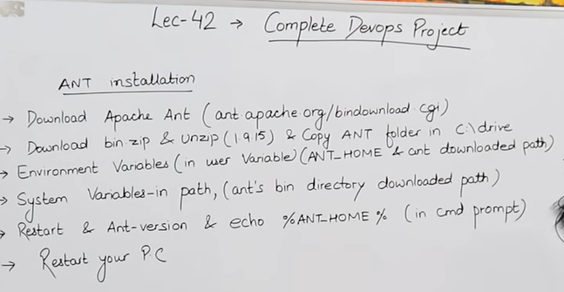

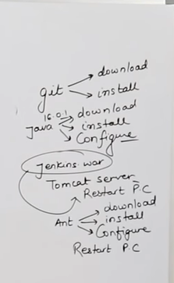

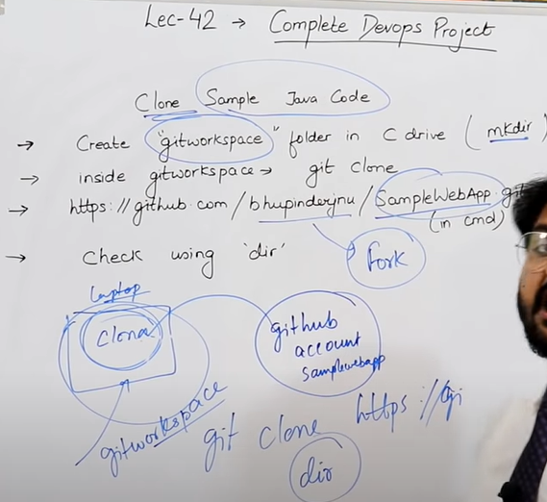

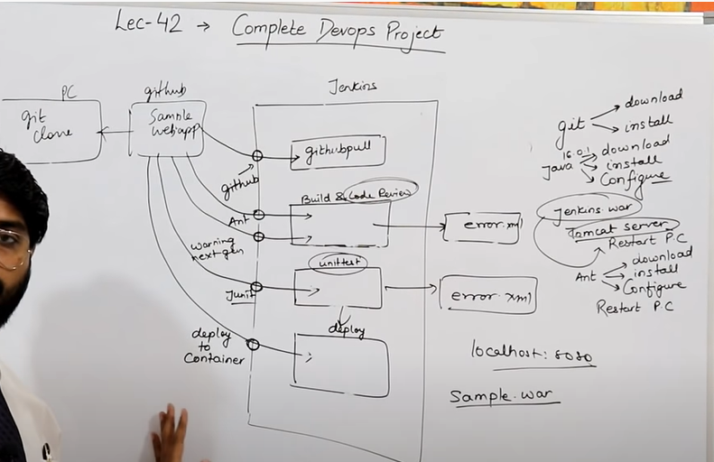

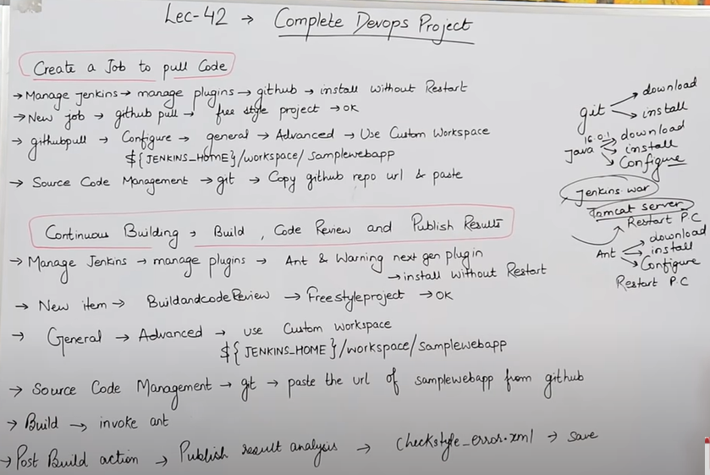

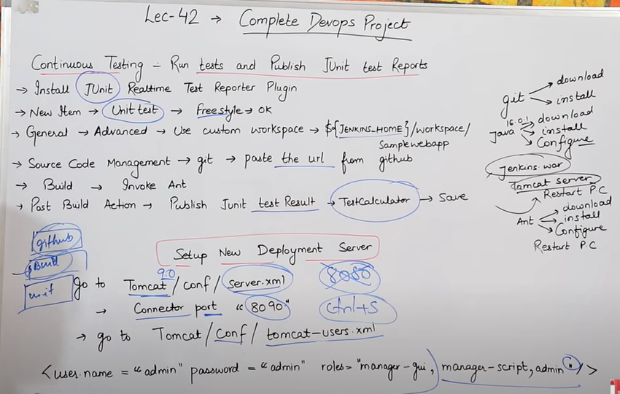

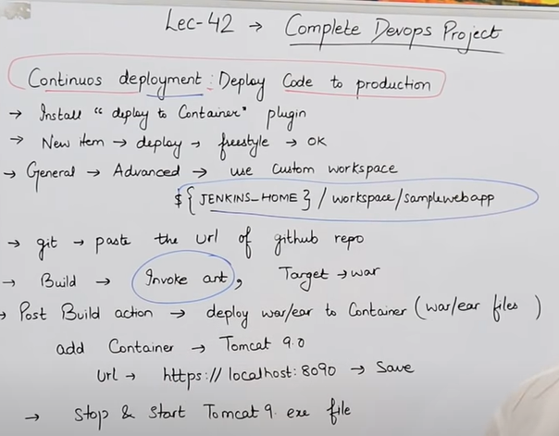

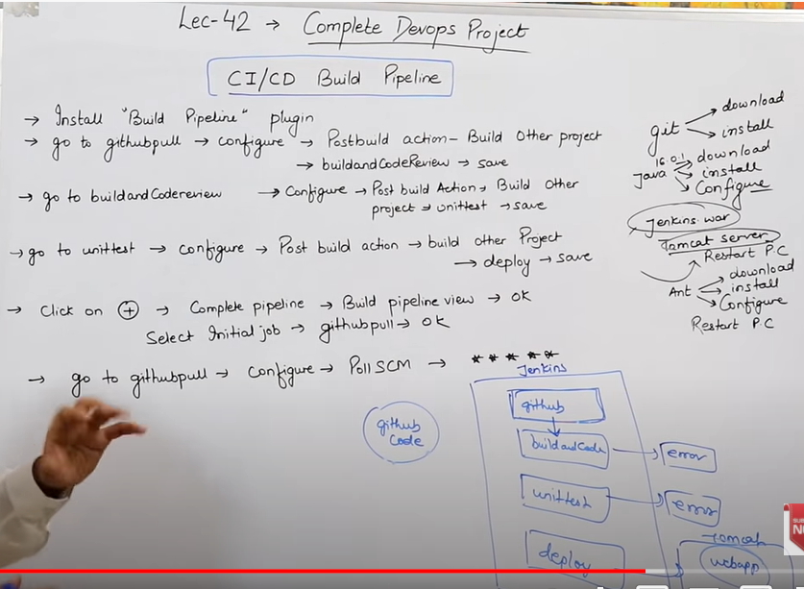

For complete CICD pipeline

Git

* Download and install git

Java

* Download, install and configure java

Jenkins

* Download Jenkins.war file form Jenkins.io/download
* Download tomcat installer windows 10
* Download apache tomcat server and install
* Jenkins.war file inside manager app
* Access Jenkins localhost:8080/Jenkins
* Make JENKINSHOME folder inside C drive and configure JENKINSHOME in environment variable

Jenkins Pipeline Jobs are created as follows and install require plugins

1. GitHubPull (Job)

* Github plugin

1. Build and Code review (Job)

* Ant plugin , Warning next generation Plugin

1. UnitTest (Job)

* JUnit Realtime test Reporter plugin

1. Deployment (Job)

-deploy to container plugin

you can see SampleWebApps in <https://localhost:8090>

CI/CD Build Pipeline

-install Build pipeline plugin

Click on + 🡪 complete pipeline 🡪Build Pipeline view 🡪 OK

Select Initial job 🡪 githubpull 🡪Ok

Go to githubpull 🡪configure 🡪 POLL SCM --🡪 * * * * *

**At Wells Fargo, we want to satisfy our customers' financial needs and help them succeed financially.. Wells Fargo Technology plays a critical role in the company's customer and employee experience, business and risk management transformation, and growth agenda. The ideal candidate provides Platform Support and Change coordination for the Cornerstone Customer Due Diligence non production and production application platforms; maintain, troubleshoot and restore service to the non production environments for testing and development use; act as an internal consultant regarding use of tools and processes to developers, QA and other support partners; supports and/or acts as the change manager/technical SME for migrations in the lower level non-production environments; perform programming to fine tune non-production systems; troubleshoots software issues and coordinates resolution with users, vendors and internal service groups; creates issue logs; assesses risk to production systems and assures quality, security and compliance requirements are met**

How to install Jenkins on Ubuntu

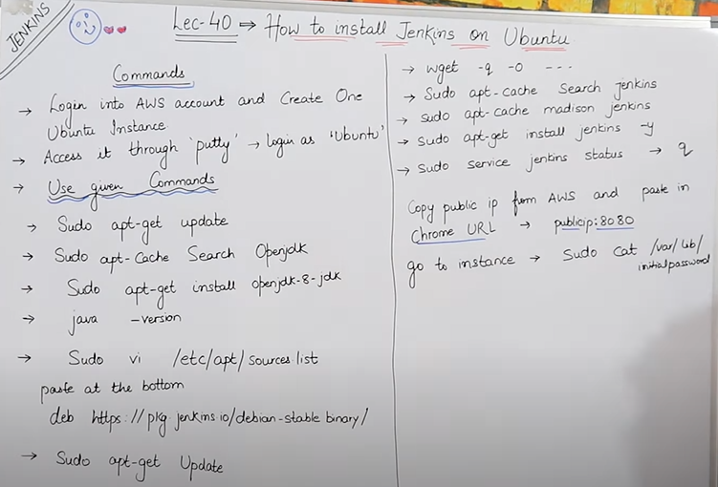

Make the ubuntu server

Login as: ubuntu

Jenkins Ubuntu url: http://44.201.223.4:8080/

username: reyona

password:admin123

Lecture:41 What is maven and why we use it?

Lecture 44: Nagios servier dashboard

